GARDEN HOSE CONNECTOR JOINER 2 WAY PLASTIC MALE TO MALE
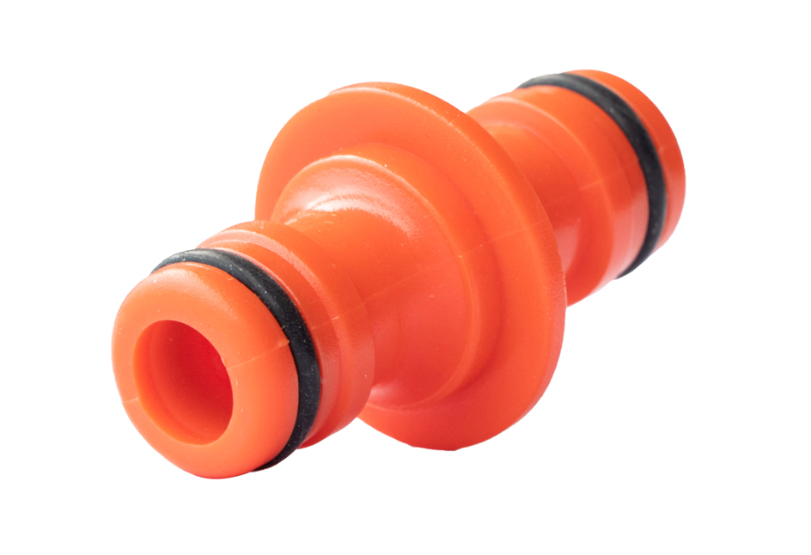
- Made of sturdy plastic, robust and rust resistant, durable material can serve a long time use
- Double male hose connectors compatible fitting for 1/ 2 Inch quick-connector from female to female hose ends
- Can be installed quickly and easily using
- Fits standard Hozelock and most quick connectors
- Part number: LMS131601
- Barcode number:8400800041067

